Protocol # | Description | Objective | Reqt/Spec | Author
 | Read and sign training | To verify:  - Read and Sign training can be created and scheduled through the index card.  - Schedule Training: on/before promotion to cabinet works as expected.  - Training Due: on/before date works as expected.  - Promotion settings work as expected.  Selected entities are assigned training as expected.  - The read and sign document which are displayed (along with differences to release).  - An entry is made to the audit log when a read and sign is complete through the web interface.

Prerequisites | - Standard System Configuration  - The user must be logged In to the web interface  - The group that the user is a member of should have “Read and write” permissions.  - The group that the user is a member of should have Training related permissions.  - Signature routes or document routes are configured.
Procedure | Part 1  - Login to the web interface as “Test User”.  - Create a new document.  - Add a main file, approvers and other required fields.  - Click on the “Training” tab.  - Change the training type to “Read and Sign”.  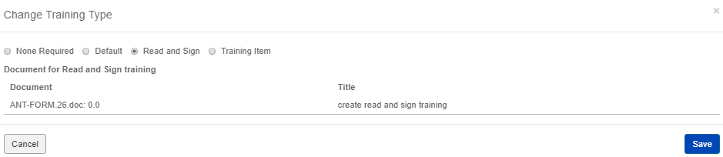  - Click on save button.  - Set “Schedule training: On promotion to the following cabinet” to “Approved”.  - For “Training due,” select the radio button “before promotion to next cabinet”.  - For “Select entities subject to training,” select the radio button “Read/Write from cabinet”.  ER 1 – The Read and Sign Training is scheduled.  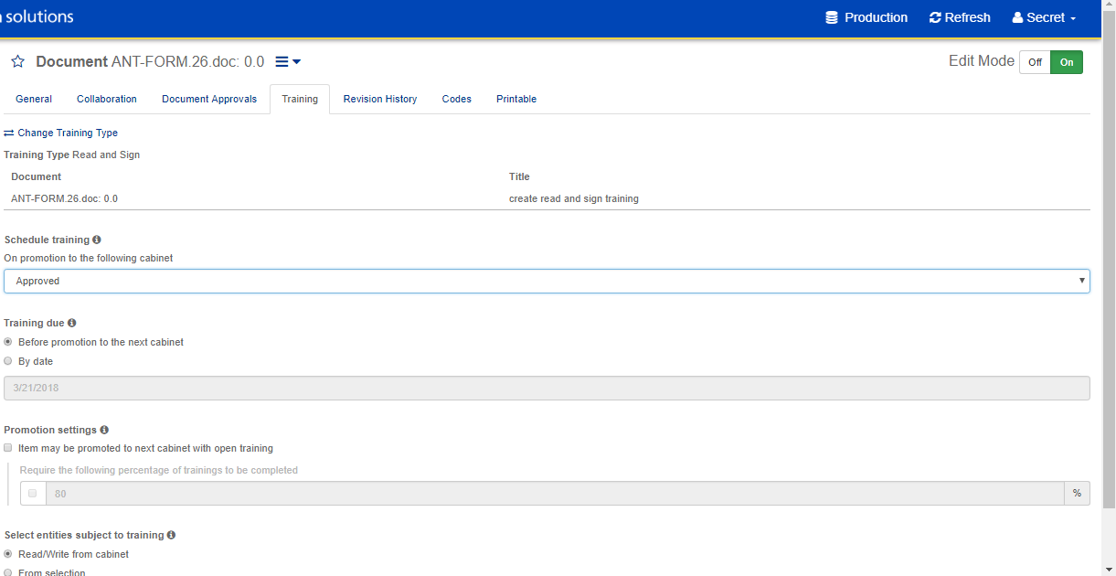  - Check in the document and route the document for approval.  ER 2 – The document is checked in and route for approval.  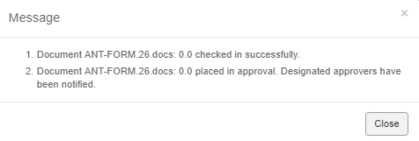  - Login with approvers login and approve the document  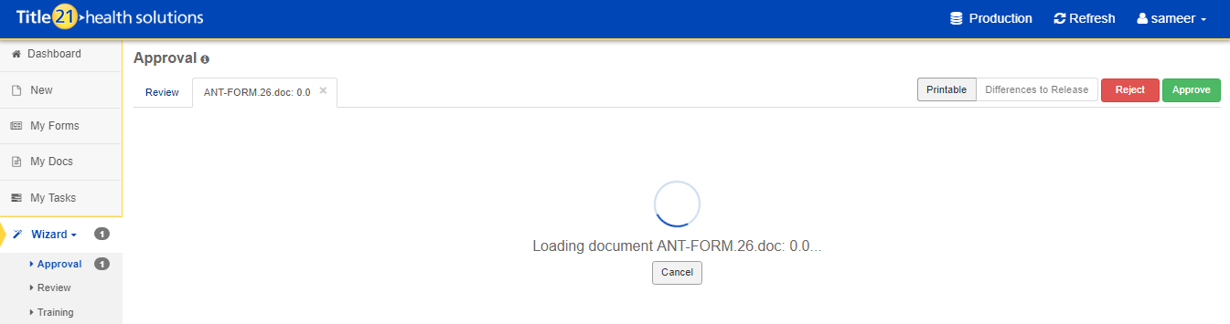  - Click on Approve button  - Enter pin and click on submit.  ER 3 – The document is approved successfully and displays the successful message.  - Go to: Wizard > Training.  ER 4 - The Read and Sign training created is available.  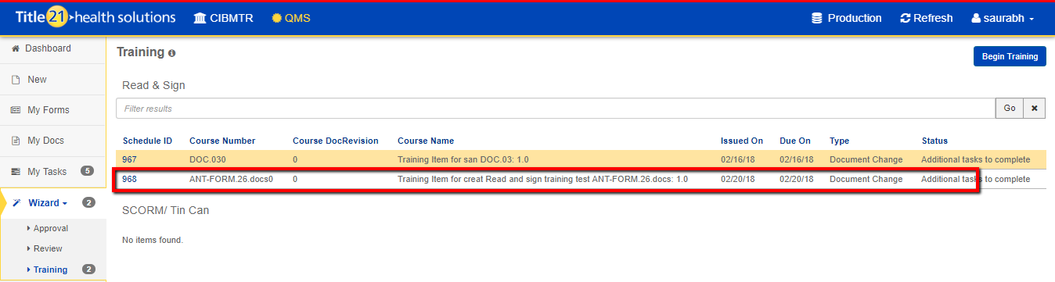  - Select training  - click on begin training  ER 5 – Details about the training document are visible  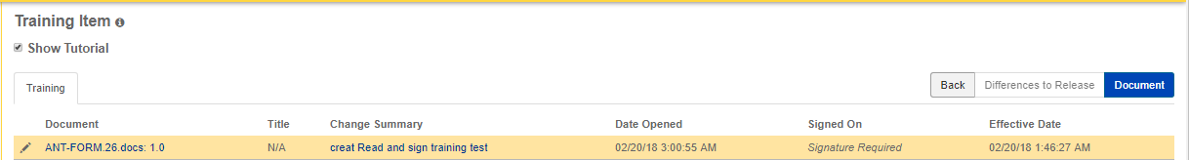  - Click on Document  ER 6 – The document should be available in a new tab with options to Sign  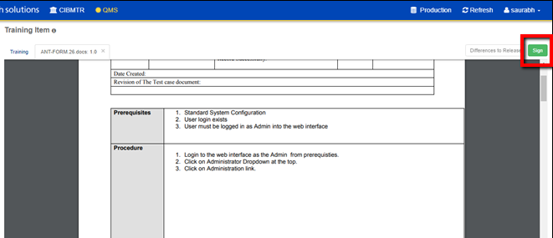  - Click on “Sign”  ER 7 – The electronic signature dialog is presented  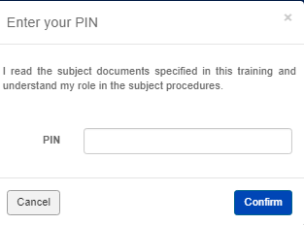  - Enter the pin and click on confirm button.  ER 8 – User is informed that the training item is completed, and the training item details are visible with the “Signed On” date updated.  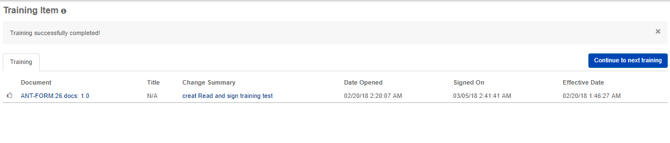  - Login as admin and navigate to audit log section.  - Search the audit log for the signature entry by the test user  ER 9 – The audit log entry for the read and sign training performed through the web interface is recorded  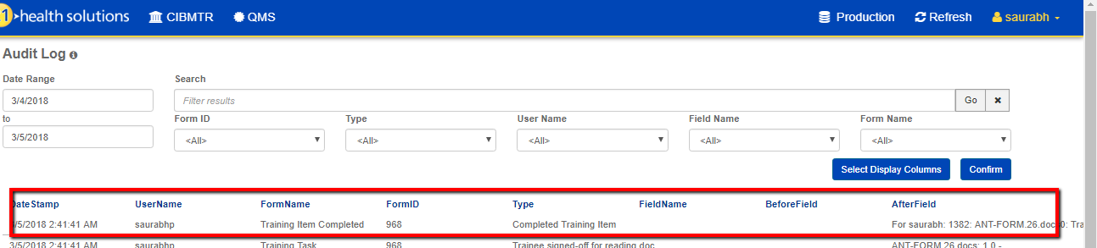  Part 2  - Create a new document.  - Ensure the document is open in edit mode.  Note: Edit mode On/Off is indicated on the top of the form and form fields are editable when it is enabled.  - Add the main file, approvers, and all the required fields.  - Set the Target Release Date to one day after the current date.  ER 10 – Target release date is set.  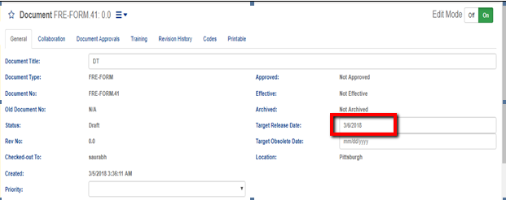  - Click on the “Training” tab.  - Select or change the training type to “Read and Sign”.  - Set “Schedule training: On promotion to the following cabinet” to “Approved”.  - For “Training due,” select the radio button “before promotion to next cabinet”.  - For “Promotion Settings”, select the checkbox “Item may be promoted to next cabinet with open training items”.  - For “Require the following percentage of training to be completed,” select the checkbox and add “50” % in the text box.  - For “Select entities subject to training,” select the “From Selection” radio button. Click on “Entities” link. Select two entities and click on “Update”.  ER 11 – The Read and Sign Training is scheduled.  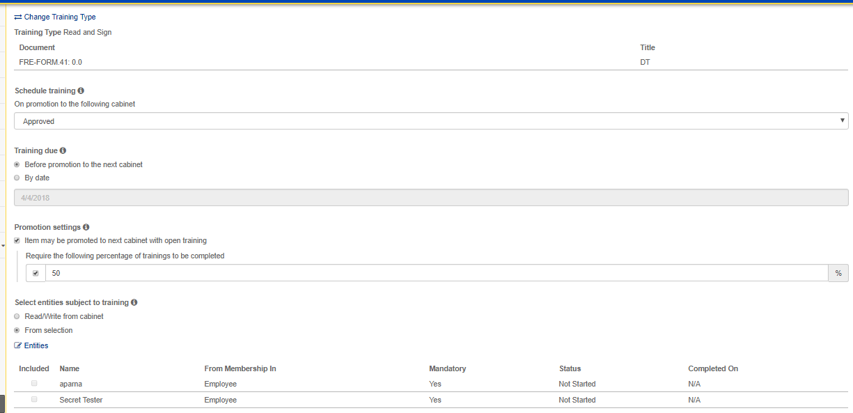  - Check in the document and route it for approval.  - Logout and login with an approver.  - Approve the document  - Logout and login with the same user used in step 22.  - Move document between cabinets through the database.  - Go to document approved in Step 35.  ER 12 – Approved document from Step 35 should not move to the effective cabinet as 50% of required training is not completed yet.  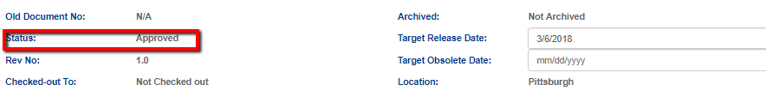  - Logout and login as one of the entity noted in Step 32.  - Navigate to Wizard > Training.  ER 13 - The Read and Sign training created in ER-11 appears.  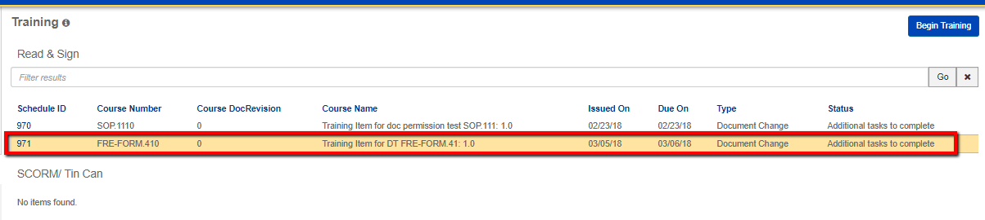  ER 14 – Training due date is same as Target release date noted in Step 20.  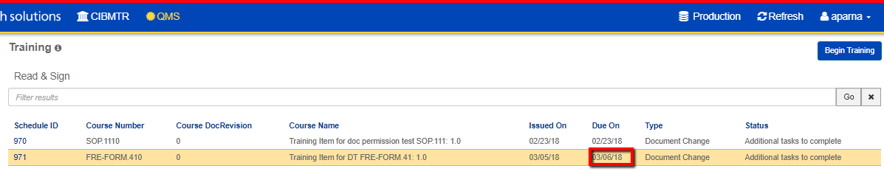  - Begin training.  - Sign/complete the training.  - Log out  - Run Jobs and Move document between cabinets through the database.  ER 15 – Job run completed.  - Log in to a user used in Step 1  ER 16 - Approved document from Step 35 should move to the effective cabinet as 50% of required training is completed.  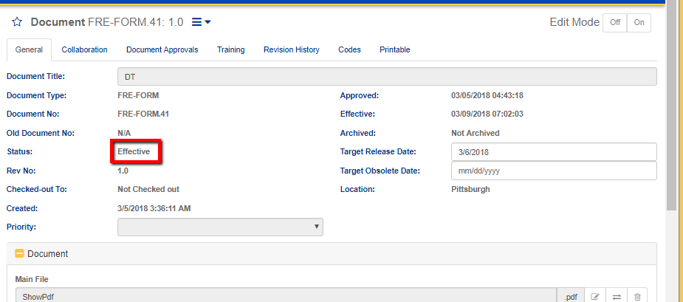  Part 3  - Create a new document.  - Ensure the document is open in edit mode.  - Note: Edit mode On/Off is generally indicated on the top of the form and form fields are editable when it is enabled.  - Add the main file, approvers, and all the required fields.  - Click on the “Training” tab.  - Select or change the training type to “Read and Sign”.  - Set “Schedule training: On promotion to the following cabinet” to “Approved”.  - For “Training due” select radio button “by date” and set that date.  - For “Promotion Settings” select the checkbox “Item may be promoted to next cabinet with open training items”.  - For “Require the following percentage of training to be completed” select the checkbox and add “50” % in the text box.  - For “Select entities subject to training” select the “From Selection” radio button. Click on “Entities” link. Select two entities and click on “Update”.  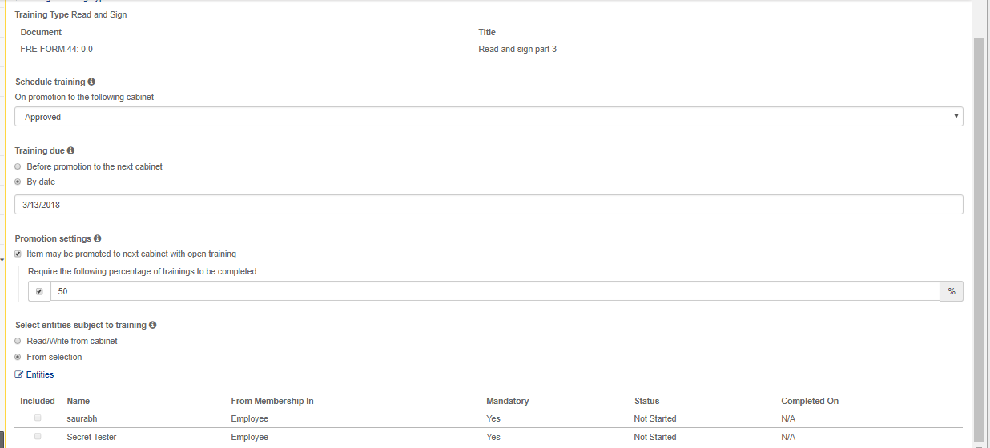  - Check in the document and route the document for approval.  - Approve the document.  - Log out.  - Log in as one of the entities noted in Step 56.  - Navigate to Wizard > Training  ER 17 - The Read and Sign training created in Step 56 appears and the due date is the same as “Training due by date” noted in step 53.  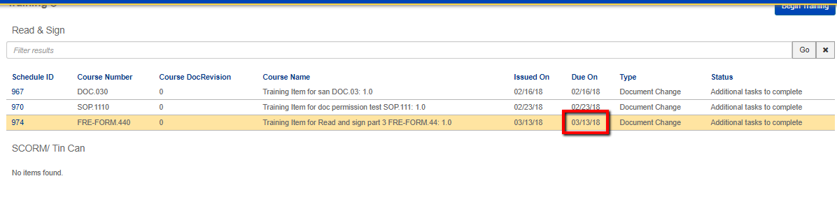
Pass/Fail | Pass:  Fail: | Type of Execution:
Pass/Fail | Pass:  Fail: | Automation: | Manual:
 | Date of Execution:
Notes/Deviations
Additional Remarks in case of Manual Execution
Name of Tester(if Manual)
Test Case Review/Approval | Signature of  Reviewer/Approver: |  |  | Date of Approval:

